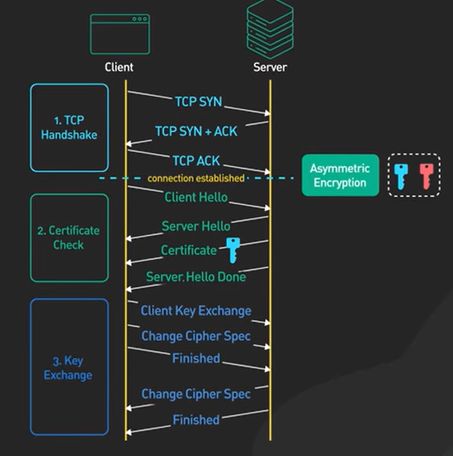

Link: <https://mahmudul-razib.medium.com/ssl-pinning-in-ios-a985895c4414>

Video: <https://www.youtube.com/watch?v=j9QmMEWmcfo>

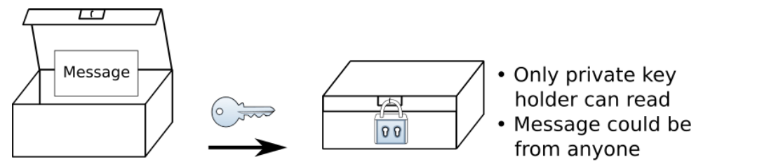

Note: Public key available to all.